Free-body diagrams
Free-body diagrams are diagrams used to show the relative magnitude and direction of all forces acting upon an object in a given situation. A free-body diagram is an example of the vector diagrams where the size of the arrow reflects the magnitude of the force and the direction of the arrow shows the direction that the force is acting. Each force arrow in the diagram is labelled to indicate the exact type of force. The box represents the object and the force arrow is drawn from the center of the box outward in the direction that the force is acting.

Describe the forces acting on objects A, B, and C as balanced or unbalanced, and then determine the net force acting on each object.
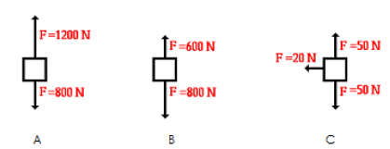
Draw the possible FBDs for the following situations. Try to think of size of each arrow depending on the information given:

1. Book at rest on a tabletop:
- Gravity: Pulling the book downwards (represented by a downward arrow)
- Normal force: Pushing the book upwards from the tabletop (represented by an upward arrow)

2. Gymnast suspended on a bar:
- Gymnast's weight: Pulling the gymnast downwards (represented by a downward arrow)
- Tension force in the bar: Supporting the gymnast's weight upwards (represented by an upward arrow)

3. Falling egg accelerating towards earth:
- Gravity: Pulling the egg downwards (represented by a downward arrow)
- Air-resistance: Pushing the egg upwards from the air (represented by an upward arrow)

4. Gliding squirrel moving with constant speed:
- Weight: Pulling the squirrel downwards (represented by a downward arrow)
- Air resistance: Pushing the squirrel upwards from the air (represented by an upward arrow)

5. Book pushed across a desk with acceleration:
- Applied force: Pushing the book to the right (represented by a rightward arrow)
- Friction force: Opposing the book's motion to the left (represented by a leftward arrow)
- Normal force: Pushing the book upwards from the desk (represented by an upward arrow)

6. Book moving at constant velocity on a desk:
- Applied force: Initially pushing the book to the right, but now balanced by the friction force (not shown)
- Friction force: Opposing the book's motion to the left, equal in magnitude to the applied force (represented by a leftward arrow)
- Normal force: Pushing the book upwards from the desk (represented by an upward arrow)

